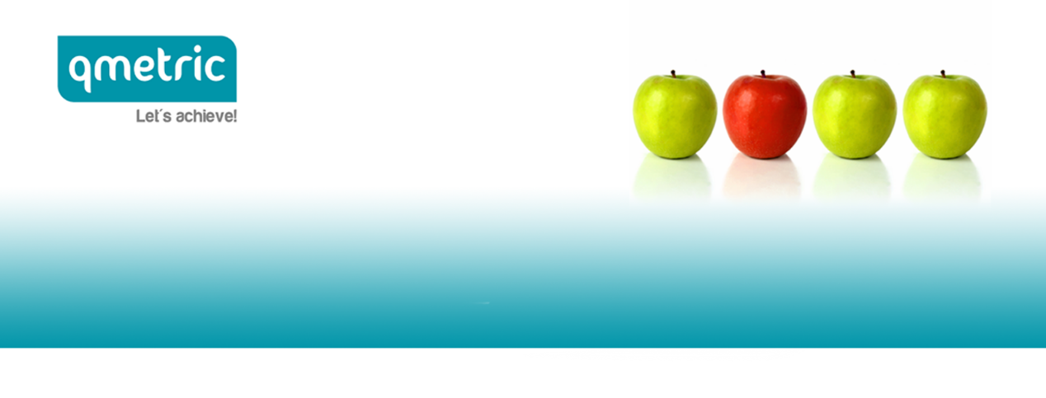

qmetric | HR Solutions is currently recruiting, on behalf of DRAXIS, the position of

Earth Observation Expert

The company

Founded in 2000 in Thessaloniki, DRAXIS focuses on developing real life environmental ICT solutions and providing specialized environmental consultation services. Looking always ahead, they keep up with and interpret what is happening in day-to-day business, so as to offer custom-made tools, reflecting their commitment to be of service to the environment we live in.

The position

You will join DRAXIS dev team in developing state of the art, custom made, IT solutions using IoT, environmental remote sensing, big data, data analytics/visualizations, geographic information system (GIS) technologies, and web/mobile applications. In case you are selected, you will be based in Thessaloniki and your main duties will include:

- Writing clean, well-structured and maintainable code by using best software development practices
- Developing tools to process Earth Observation data used in the view of extracting features or analysis
- Development and testing of the components and interfaces using continuous integration
- Coordinating with commercial partners who will use the components to develop their own services or will provide data to our systems
- Designing of Features Extraction components and interfaces.

Your profile

In order for you to be able to successfully carry out the duties of the job, you should possess the following:
- Expert understanding and experience in earth observation having proven work experience for 2+ year
- Good knowledge of one programming language: Python, R, Java
- Experience with OGC web interface (WMS, WCS, WFS)
- Excellent knowledge of spatial databases (MySQL or PostgreSQL) and queries
- Experience with GIS tools like QGIS, GDAL
- Understanding and implementation of complex architecture and ability to design/propose solutions to fit complex IT problems.

Desirable
- Experience with Docker
- Experience in image processing algorithms, classification, object detection.

Our Client offers

In case you are selected for the specific position, you will join DRAXIS growing team and have access to the following:

- Work in a dynamic and friendly environment
- Gorgeous office space
- Grow by learning from the team or by using the annual training budget for a topic you are passionate about
- Get the chance to work in different projects building up the company’s and your portfolio
- Get a competitive salary, plus a private health insurance program.

Are you interested?

Are you thrilled by the prospect of advancing your already successful career and developing professionally in an innovative and fast-growing company?
If so, please click here to submit your application!

Our company treats each application with strict confidence and is fully complied with EU General Data Protection Regulation.

