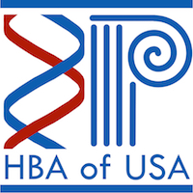

Hellenic Bioscientific Association of the USA

**Scholarship Program 2017**

**Notice of Invitation**

The Hellenic Bioscientific Association in the USA (HBA-USA) [www.hbausa.org](http://www.hba-usa.org/) announces the establishment and initiation of the Scholarship Program.

The Scholarship Program aims to award one scholarship per year to a student who has been accepted by a U.S. University for graduate studies. The scholarship amount during the launch of the program will be $1,000 but is expected to increase in subsequent years pursuant to the fundraising activities of HBA-USA. Collectively, the Scholarship Program intends to recognize and support biomedical scientists of Greek origin during their transition from the undergraduate studies to graduate school in an institution at the USA.

**Eligibility**

All applicants must meet the following eligibility requirements:

1) They are members of HBA-USA

2) They are of Greek origin (Greek or Greek-Americans)

3) They have been accepted by a U.S. University to pursue a Masters or a Doctorate degree in the biological/biomedical sciences and engineering (graduate program starting in Fall 2017).



All applications will be evaluated by the scientific advisory board. The awarded student will be selected based on their credentials. We invite students to send their CV, the official acceptance letter from the US University and a letter of interest (not to exceed 300 words) at [administrator@hba-usa.org](mailto:administrator@hba-usa.org) by March31st, 2017.

