Junior JAVA Developer
REF: JSW2/10/18, Athens, Greece
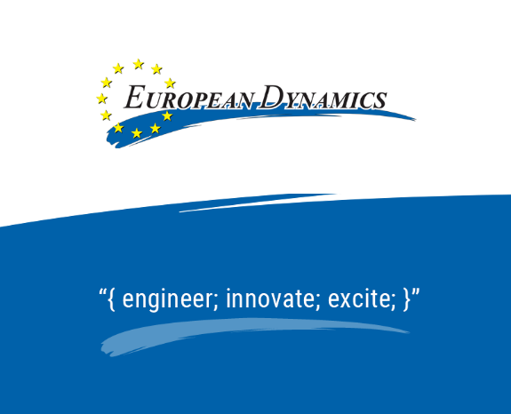
EUROPEAN DYNAMICS (www.eurodyn.com) is a leading Software, Information and Communication Technologies company, operating internationally (Athens, Brussels, Luxembourg, Copenhagen, Berlin, Berne, Stockholm, London, Helsinki, etc.). The company employs over 500 engineers and IT experts. We design and develop software applications using state-of-the-art technology. Our current ICT projects have a value exceeding 200 million EURO. EUROPEAN DYNAMICS is a renowned supplier of IT services to European Union Institutions, international organizations, European Agencies and national government administrations internationally.
We currently have a vacancy for a highly motivated Junior JAVA Developer, passionate with development and maintenance of JEE based applications and fluent in English. The developer will offer his/her services in the Athens office. In the context of the first assignment, the successful candidate will be integrated in a Project team for a major client.
Main responsibilities and Tasks
By applying your knowledge and experience you will participate in the design and development of multi-tier and web-based applications. More analytically you will be engaged in:
- Design, development and testing components of complex web-based Java applications;
- Collaborating passionately with colleagues, adhering to high professional standards and ensuring the delivery of quality software;
- Drafting technical documentation and provision of support during deployment and configuration phases.
Qualifications
- Bachelor's degree in computer science or a related technical field or equivalent work experience;
- Ability to work both independently and in a team-oriented collaborative environment;
- Fluency in English.
- Minimum 1 year experience in Java and enthusiasm for programming;
- Experience in some of the following technologies is considered an asset: Java Enterprise Edition (JEE), OSGi, AngularJS, JavaScript, XML/XSD, XSL, SQL.
Our Offer
As a Junior JAVA Developer you will have the opportunity to explore and apply the latest development tools/technologies. As part of a friendly team you will work closely with a highly professional team of full-stack software developers / engineers. As part of an international company you will contribute to challenging IT software projects for major international public organizations and institutions. As part of a dynamic company you will get the chance to develop your skills and your career.
We offer a competitive remuneration (with full benefits package) based on qualifications and experience, including:
- Competitive full-time salary;
- Private Health Coverage on the Company’s group program;
- Flexible working hours, top - of - the Line tools, language courses, specialized trainings;
- A great opportunity to grow and work with innovative and exiting specialists in the industry;
- Being part of an environment that offers challenging goals, autonomy and mentoring, which creates development opportunities, both for you and the company.
If you want an exciting challenge, work with some of the coolest technologies and enjoy your time doing it, then join us! Send us your detailed CV in English, quoting reference: (JSW2/10/18), to the following link: https://european-dynamics.workable.com/j/4BE8AF857F
As part of our dedication to the diversity of our workforce, we are committed to Equal Employment Opportunity without regard for race, color, national origin, ethnicity, gender, disability, sexual orientation, gender identity, or religion.
EUROPEAN DYNAMICS (ED) adheres to the General Data Protection Regulation principles by applying its Privacy Policy as published in www.eurodyn.com/privacy. By sharing your personal data with ED, you acknowledge and accept its Policy and authorise ED to assess your candidature and communicate with you in relation to the job opening.
Furthermore, when providing your data, it is up to you to explicitly consent that your data can be assessed for future job openings, for as long as you do not withdraw such consent. If you do not consent, we will not be able to consider the data you provide to us for future job openings.

